- Open the following link and click “Parallels Remote Application Server”:
https://www.parallels.com/
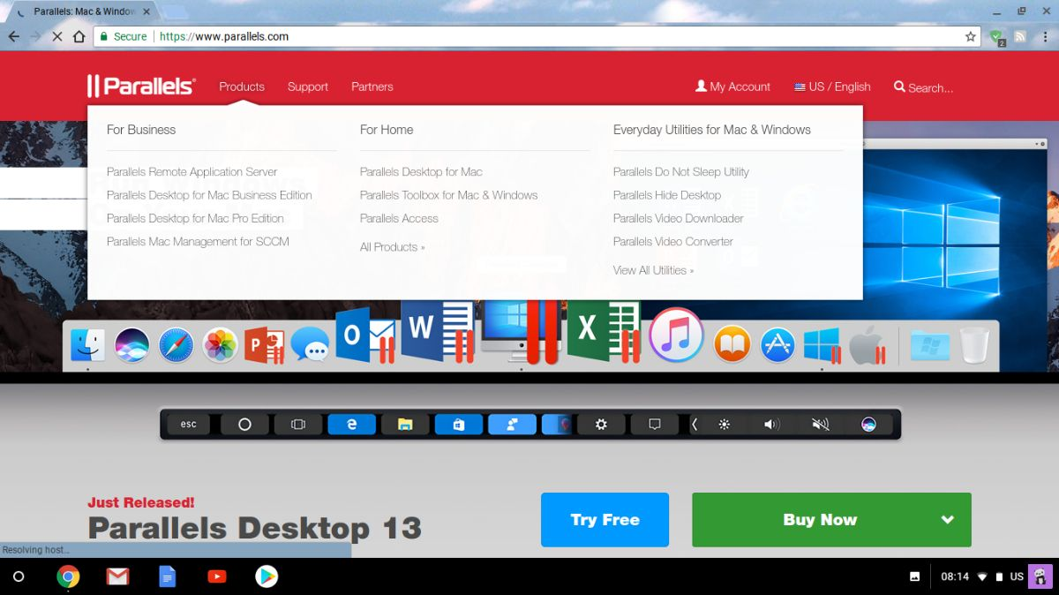

- Click “Parallels Client”:
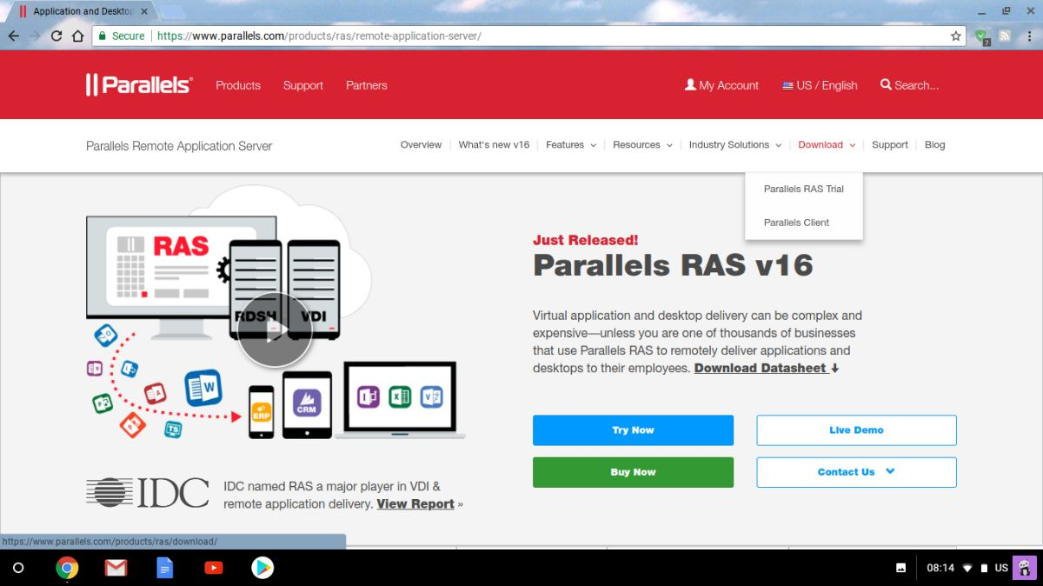

- Switch to “Chrome” tab and download Client from Chrome Web Store:

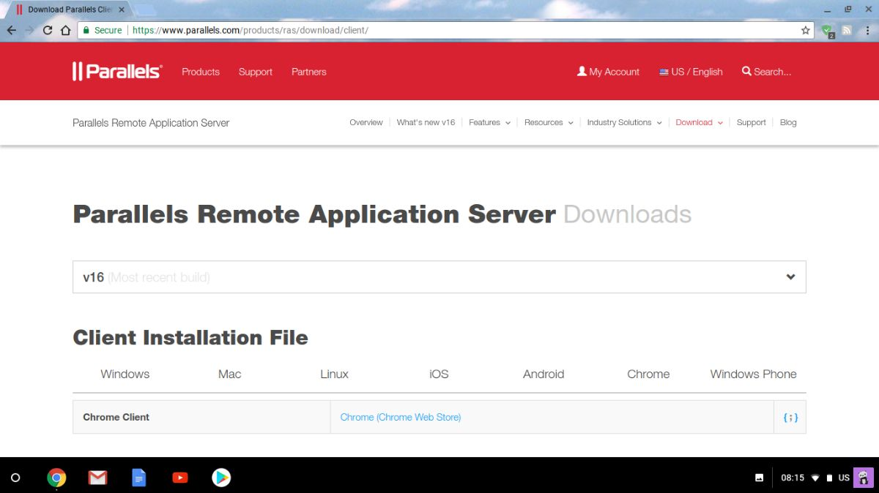

- Open “Downloads”:
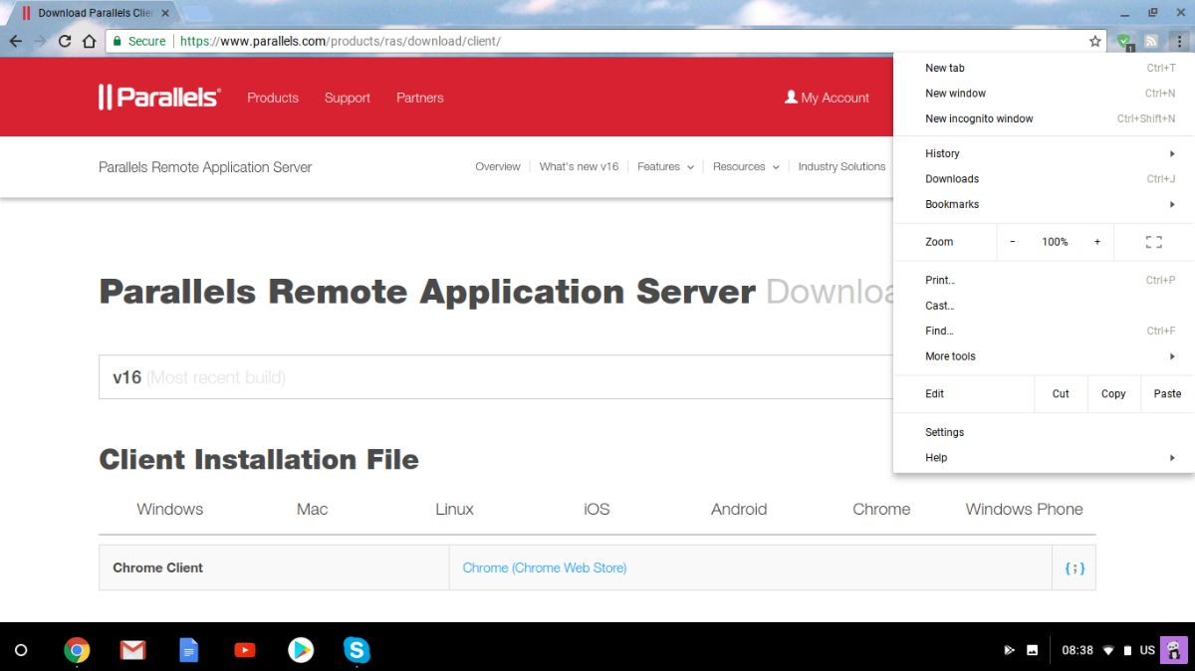

- Click “Show in folder”:
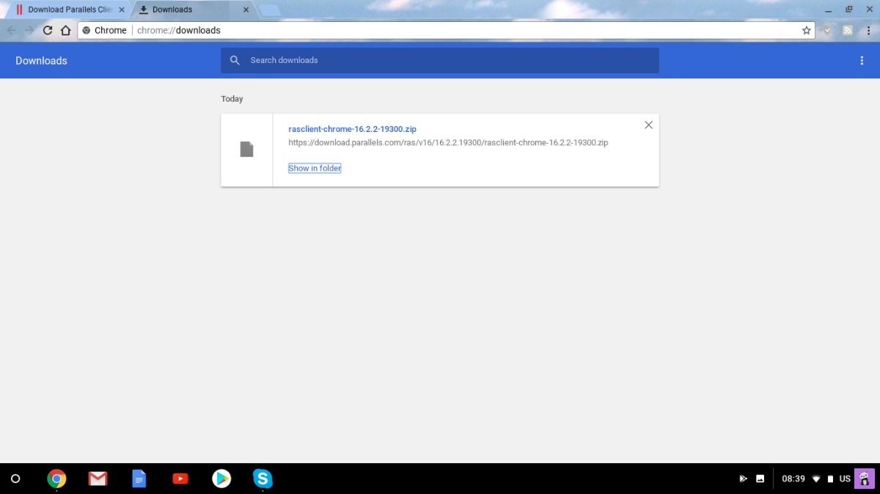

- Press “Ctrl+A” to select all items, and then “Ctrl+C” to save them to clipboard:
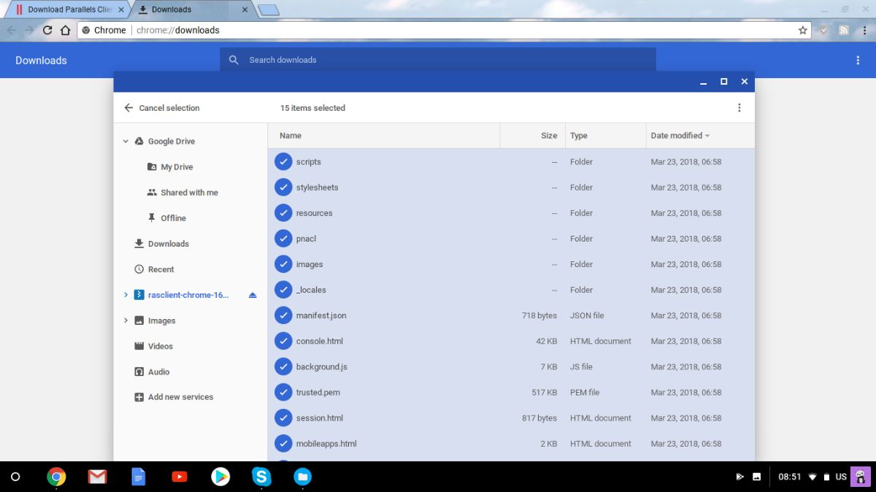

- Open Start menu > Files
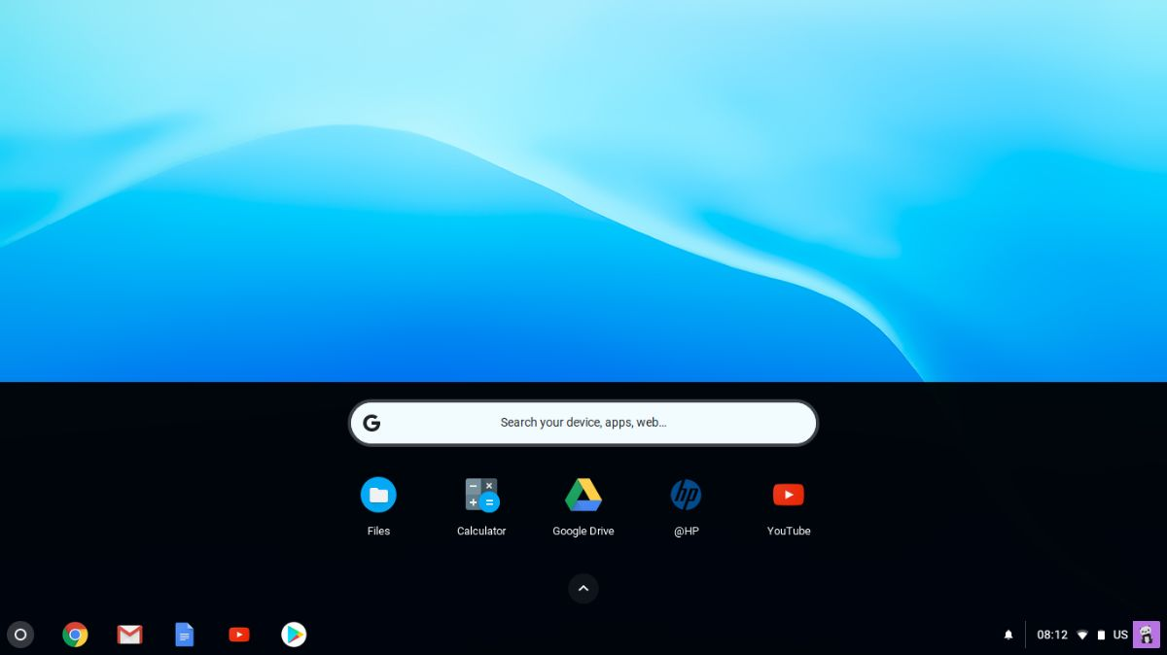

- Create folder in “Downloads”:
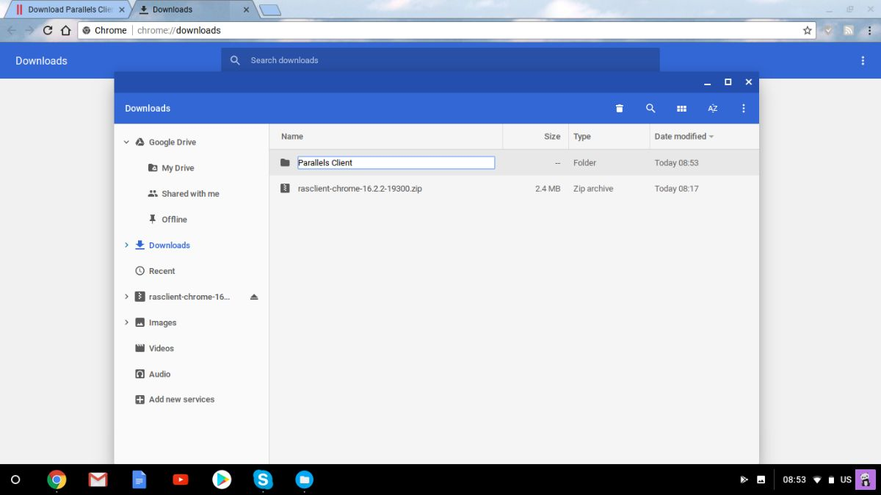

- Open the newly created folder and press “Ctrl+V” to paste all items:

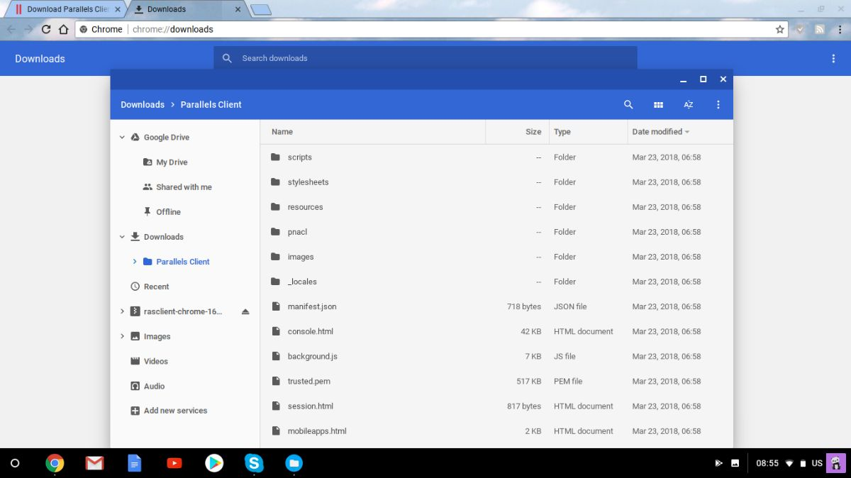

- Open Browser settings > More Tools > Extensions:

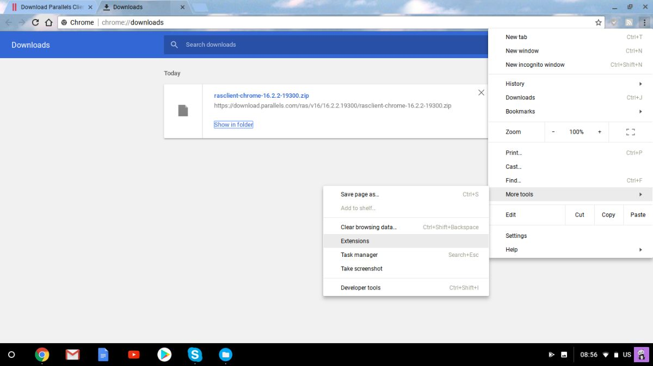

- Click “LOAD UNPACKED”:

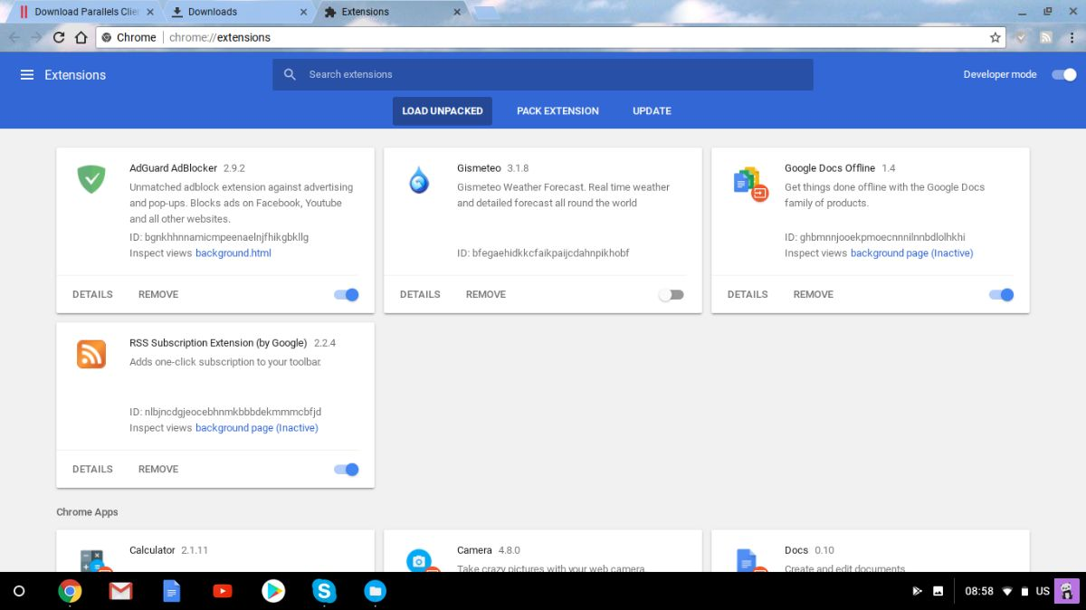

- Choose the previously created folder and click “OPEN”:

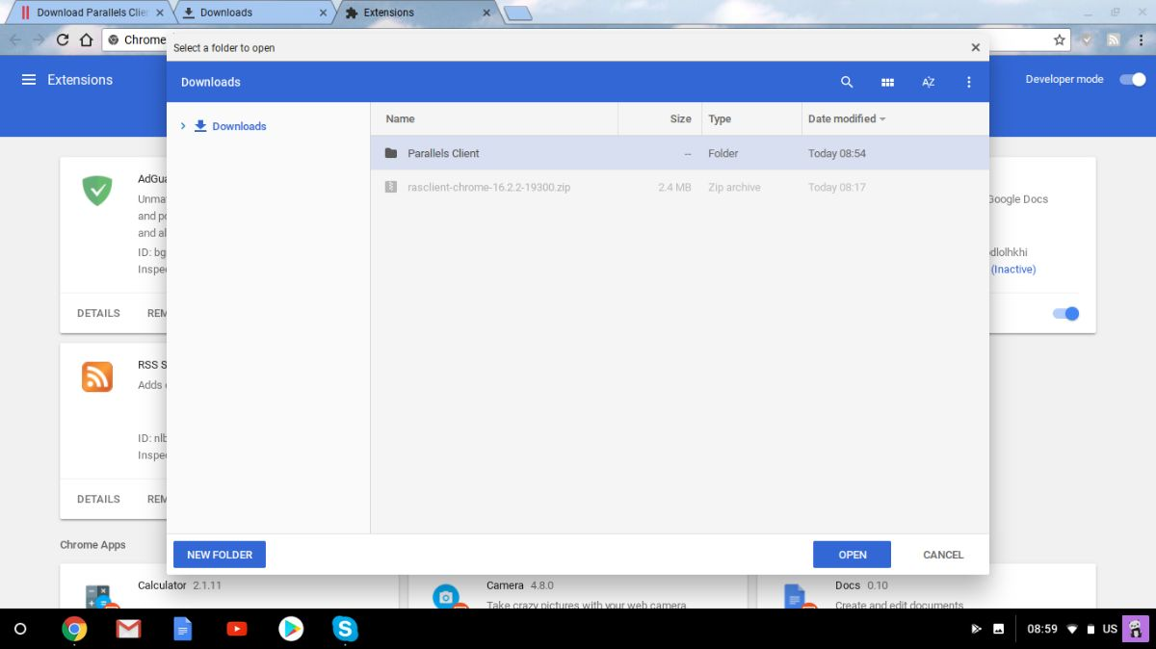

- Parallels Client should now be listed in extensions:
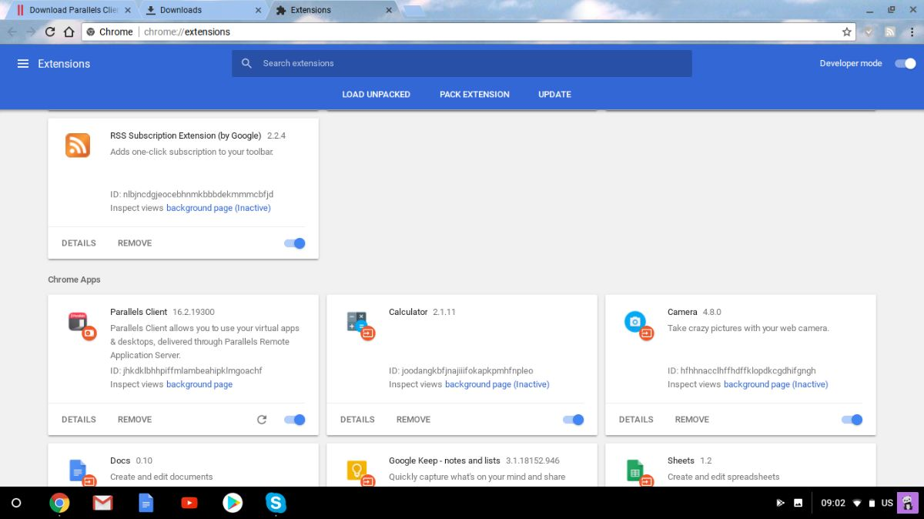

- If you press “Start” button now you should see Parallels Client and launch it:

